Celebrating Reconciliation Grants Program

Promotional Toolkit
Acknowledgment of Country
We pay our respects to the Aboriginal and Torres Strait Islander ancestors of this land, their spirits and their legacy. The foundations laid by these ancestors gives strength, inspiration and courage to current and future generations, towards creating a better Queensland.

About the grants
The Celebrating Reconciliation Grants Program is designed to support events and activities held in or around National Reconciliation Week.
Key criteria for events and activities are to:
- promote and facilitate respectful relationships between Aboriginal, Torres Strait Islander and non-Indigenous Queenslanders
- promote and strengthen relationships between Aboriginal, Torres Strait Islander and non-Indigenous Queenslanders
- promote inclusion and social cohesion
- raise community awareness of National Reconciliation Week, held annually from 27 May to 3 June
- offer community members opportunities to learn, share, and grow—for example, through sharing stories, and showcasing local Aboriginal and Torres Strait Islander histories, arts and cultural activities.

The Celebrating Reconciliation Grants 2026 will support Queensland-based reconciliation events held in or around National Reconciliation Week 2026. Organisations will be able to apply for grants of up to $2,500 (exclusive of GST) per event or activity. A total of $100,000 in grant funding is available.

Key messages
- National Reconciliation Week, held annually from 27 May to 3 June, celebrates and builds on respectful relationships shared by Aboriginal, Torres Strait Islander and non-Indigenous Australians.
- The week is an opportunity for all Australians to learn about our shared histories, cultures and achievements and to explore how each of us can support the national reconciliation effort.
- The Celebrating Reconciliation Grants supports Queensland-based reconciliation events held in or around National Reconciliation Week 2026 (in May or June).
- Grants are available to the value of up to $2,500 (exclusive of GST) per event or activity.
- Applications open Thursday 26 February 2026.

- Applications close at 8:00am on Tuesday 10 March 2026.

Key dates
- At 8:00am on Thursday 26 February 2026: Grant applications open
- At 8:00am on Tuesday 10 March 2026: Grant applications close
- On 20 April 2026: Grant recipients announced
- May to June 2026: National Reconciliation Week events

Promotional assets
This toolkit provides content and promotional assets (e.g. newsletter content and social media images) that can be used to raise awareness of the Celebrating Reconciliation Grants and encourage applications.
Download the promotional assets here.
This promotional URL (short URL) will direct people through to existing campaign web content.
www.qld.gov.au/recgrants

Newsletter content
Applications now open for Celebrating Reconciliation Grants
The Queensland Government Celebrating Reconciliation Grants are now open with $100,000 in funding available to help Queensland communities come together for National Reconciliation Week 2026.
Eligible organisations can apply for grants of up to $2,500 for events that support reconciliation between Aboriginal, Torres Strait Islander and non-Indigenous Queenslanders.
Celebrating Reconciliation Grants supports Queensland-based reconciliation events held in or around National Reconciliation Week (27 May to 3 June).
- Applications open at 8:00am on Thursday 26 February 2026 and close at 8:00am on Tuesday 10 March 2026.
To find out more about the Celebrating Reconciliation Grants, including how to apply, visit www.qld.gov.au/recgrants

Newsletter - header

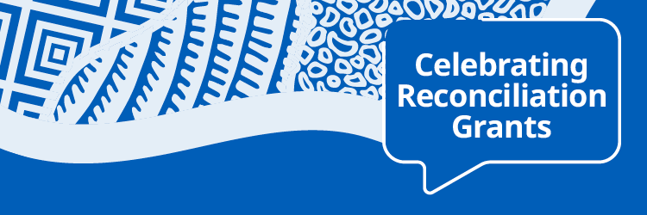

Newsletter - footer



Website content
The Queensland Government Celebrating Reconciliation Grants are now open.
Grants of up to $2,500 are available to support National Reconciliation Week events and activities across Queensland. Applications close at 8:00am on 2 March 2026.
National Reconciliation Week (27 May to 3 June) celebrates and builds on respectful relationships shared by Aboriginal, Torres Strait Islander and non-Indigenous peoples.
To find out more, more visit www.qld.gov.au/recgrants

Website tiles

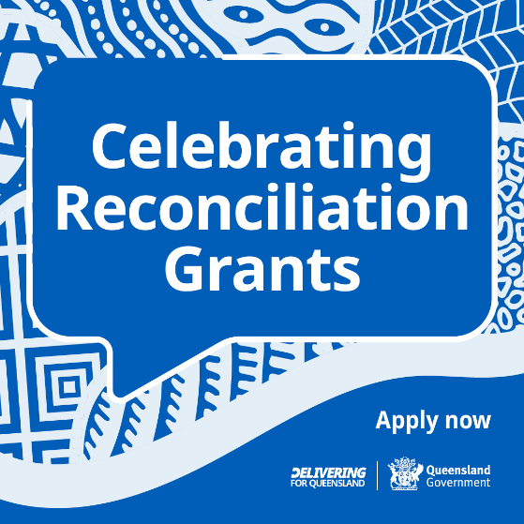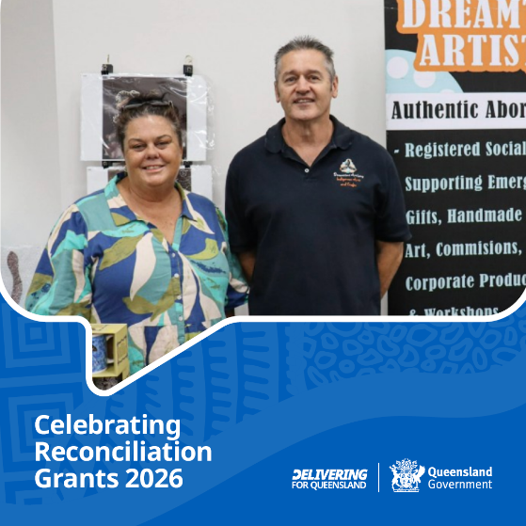

Social Media
Do you have an idea for an event or activity that promotes reconciliation?
Applications are now open for the Celebrating Reconciliation Grants, proudly supported by the Queensland Government to help communities come together for National Reconciliation Week 2026 (27 May to 3 June).
Eligible organisations are invited to apply for grants of up to $2,500 per event or activity.
Applications close 8am on 10 March 2026.
Find out more about the program and how to apply at www.qld.gov.au/recgrants
#QldReconciliationGrants #NRW2026

Social media tiles

Tile 1 (1080 x 1350)
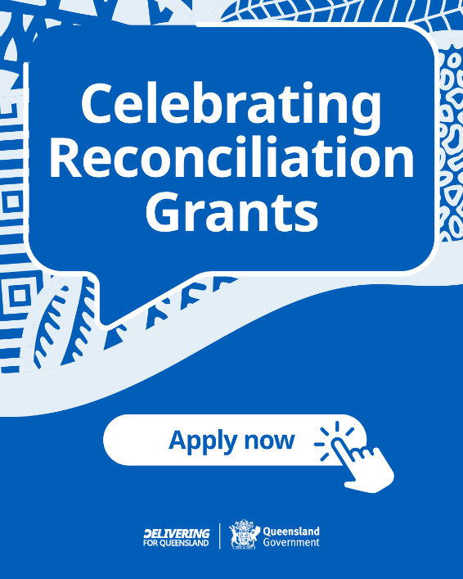

Tile 2 (1080 x 1350)
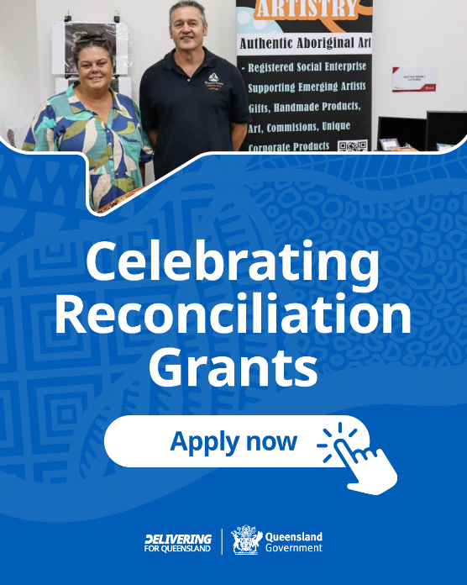

Further information
For more information about Celebrating Reconciliation Grants contact:
Strategy Insights and Communications
Email: communications@dwatsipm.qld.gov.au

