Promotional Toolkit
Indigenous Business Month 2025

Acknowledgment of Country
We pay our respects to the Aboriginal and Torres Strait Islander ancestors of this land, their spirits and their legacy. The foundations laid by these ancestors—our First Nations peoples—gives strength, inspiration and courage to current and future generations, towards creating a better Queensland.

About Indigenous Business Month 2025
Each October the spotlight shines on Indigenous Business Month (IBM), an exciting opportunity to celebrate the innovation, leadership and successes of Aboriginal and Torres Strait Islander owned businesses; while recognising the cultural and economic contributions they make to Queensland and beyond.
This year’s theme, Strength through Collaboration, highlights the unstoppable power of Aboriginal and Torres Strait Islander businesses working together and teaming up with allies. It’s all about forging trust, tackling challenges together, and creating game-changing partnerships that deliver long-term benefits.
Queensland is proud to be home to a strong and diverse network of Aboriginal and Torres Strait Islander owned businesses that provide exceptional services across all sectors. Procuring from these businesses not only supports economic empowerment and growth at local, regional and state levels but also creates jobs, builds skills and strengthens communities.
The Queensland Government recognises the importance of economic prosperity for all Queenslanders and supports IBM as an opportunity to celebrate the achievements of Aboriginal and Torres Strait Islander owned businesses and showcase their role in growing the state’s economy and creating a brighter future for all Queenslanders.
Get involved – show your support
You can support Indigenous Business Month by:
- sharing this toolkit with your stakeholders
- hosting a special event or attending events in your local area
- sharing content in this kit on your channels to raise awareness throughout the month
- consider engaging with Aboriginal and Torres Strait Islander owned businesses to increase your supply chain
For more information visit http://www.business.qld.gov.au/ibm

Key messages

- Indigenous Business Month (IBM) is celebrated every October across Australia, showcasing the innovation, resilience and leadership of Aboriginal and Torres Strait Islander owned businesses.
- This year’s theme, Strength through Collaboration, highlights the value of meaningful partnerships between First Nations businesses and their allies to build trust, access market opportunities and achieve shared goals.
- IBM shines a spotlight on the growing success and talents of Aboriginal and Torres Strait Islander owned businesses in Queensland, which deliver high-quality, cost-effective products and services across all sectors.
- Partnering with Aboriginal and Torres Strait Islander owned businesses unlocks economic opportunities, strengthens industries and fosters more resilient communities.
- From construction to technology and beyond, Aboriginal and Torres Strait Islander owned businesses offer a broad range of opportunities to engage.
- Consider engaging with Aboriginal and Torres Strait Islander owned businesses to diversify and strengthen your supply chain.
- Procuring from Aboriginal and Torres Strait Islander owned businesses is a powerful way to create positive change, support economic empowerment, generate jobs, build skills and strengthen communities.
- You can connect with Aboriginal and Torres Strait Islander owned businesses through Queensland’s Black Business Finder, Supply Nation, and the national Office of the Registrar of Indigenous Corporations - trusted databases of verified First Nations businesses in Australia.
- IBM is an opportunity to promote and support Aboriginal and Torres Strait Islander owned businesses by hosting or participating in local events throughout October.
- Register and find events in your area by visiting business.qld.gov.au/ibm and indigenousbusinessmonth.com.au.
- Share your stories and support IBM by using #IBM2025, #IndigenousBusinessMonth, #StrengthThroughCollaboration and #IndigBizMonth on social media.

Promotional Assets
Below you will find a suite of promotional materials to use in promoting Indigenous Business Month 2025.
Download the promotional assets here.

Newsletter content

Instructions
Copy and paste the copy below into your organisation’s newsletter/eDM.

Newsletter/eDM copy — under 250 words
Subject: Ready to make a difference? Let’s celebrate Indigenous Business Month together
Get ready, Queensland! From 1 to 31 October, it’s time to celebrate the innovation, resilience, and leadership of Aboriginal and Torres Strait Islander owned businesses during Indigenous Business Month (IBM).
This year’s theme, Strength through Collaboration, highlights the value of meaningful partnerships between First Nations businesses and their allies. Whether it’s two businesses pairing up or a whole community coming together, it reminds us that strong partnerships built on trust and shared goals create real, lasting impact.
Why support Aboriginal and Torres Strait Islander owned businesses?
Everytime you do you’re helping to:
✨ Fuel economic empowerment
✨ Create opportunities in local industries
✨ Build stronger, more connected communities
How can you support this Indigenous Business Month?
🎯 Diversify your supply chain by engaging with Aboriginal and Torres Strait Islander owned businesses. Find trusted businesses through:
- Queensland’s Black Business Finder: https://gateway.icn.org.au/bbf
- Supply Nation: https://supplynation.org.au/
- Office of the Registrar of Indigenous Corporations: https://www.oric.gov.au/
📣 Host or attend local events to spotlight the innovation and creativity of Aboriginal and Torres Strait Islander owned businesses. You can find local events or register your own event by visiting business.qld.gov.au/ibm and indigenousbusinessmonth.com.au.
📲 Share your IBM stories and moments celebrating achievements social media and use the hashtags: #IBM2025, #IndigenousBusinessMonth, #StrengthThroughCollaboration, #IndigBizMonth.
For more information on IBM visit http://www.business.qld.gov.au/ibm

Newsletter/eDM images
The below graphics can be inserted into your newsletter EDM to add interest to the story.
- Template header/footer: 650 pixels (W) x any height
- Images left hand placement: 250 pixels (W)
- Images full width: 550 pixels (W)
- Video full width: 550 pixels (W)
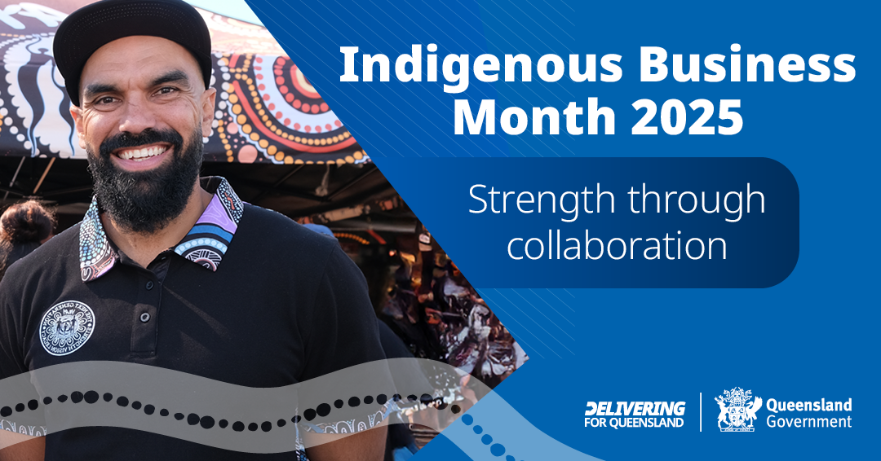

Social Media
Option one
It’s @IndigenousBusinessMonth! 🎉
This October, we’re celebrating the innovation, resilience, and leadership of Aboriginal and Torres Strait Islander owned businesses.
This year’s theme, Strength through Collaboration, highlights the power of partnerships to achieve shared goals.
By supporting First Nations owned businesses, you’re helping to:
✨ Fuel economic empowerment
✨ Create opportunities in local industries
✨ Build stronger, more connected communities
📌 Find out what events are taking place near you: business.qld.gov.au/ibm
#IBM2025 #IndigenousBusinessMonth #StrengthThroughCollaboration #IndigBizMonth
Option two
Queensland is proudly home to a thriving network of Aboriginal and Torres Strait Islander owned businesses across every industry. 💼💡
This @IndigenousBusinessMonth (IBM) is the perfect opportunity to diversify your supply chain and show your support for these incredible businesses.
Looking for trusted partners? Explore:
🔗 Queensland’s Black Business Finder: https://gateway.icn.org.au/bbf
🔗 Supply Nation: https://supplynation.org.au/
🔗 Office of the Registrar of Indigenous Corporations: https://www.oric.gov.au/

Learn more and find events happening in your local community at: business.qld.gov.au/ibm
#IBM2025, #IndigenousBusinessMonth, #StrengthThroughCollaboration, and #IndigBizMonth.
Option three
“@IndigenousBusinessMonth (IBM) gives Aboriginal and Torres Strait Islander owned businesses like mine a platform to showcase our work and inspire the next generation of First Nations business owners,” says Josh Fauid, co-founder of @AtheThreads.
Celebrate IBM this October by attending local IBM events or hosting an event in your community ✅ Partnering with First Nations business owners ✅ Sharing your stories with #IBM2025, #IndigenousBusinessMonth, #StrengthThroughCollaboration, and #IndigBizMonth ✅
Learn more at business.qld.gov.au/ibm

Hashtags
#IndigenousBusinessMonth #IBM2025 #IndigBizMonth #StrengthThroughCollaboration

Social media tiles
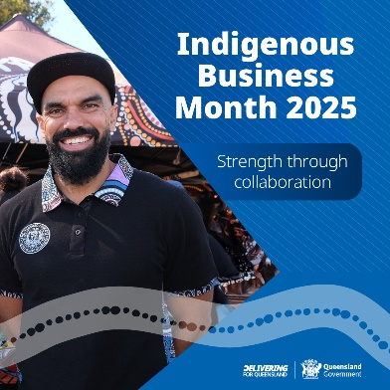
- Social media tile square (1080 x 1080px)
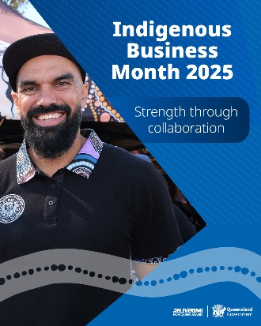
- Social media tile portrait (1080 x 1350px)
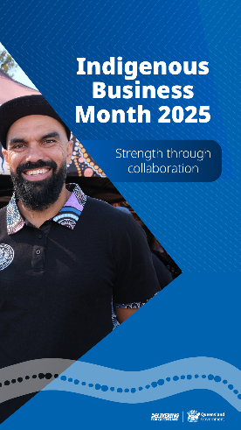
- Social media tile story (1920 x 1080px)
- Social media tile landscape (566 x 1080px)

Additional campaign materials

Campaign posters
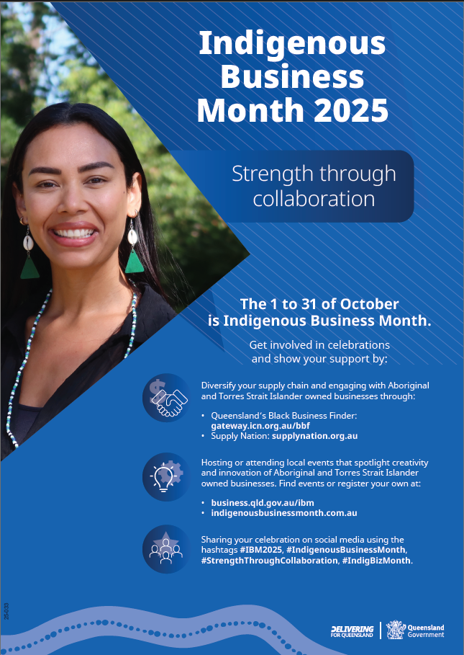
- A3 campaign poster (297 x 420mm)
- A4 campaign poster (210 x 297mm)

Newsletter assets
- Newsletter image (350 x 250px)

- Newsletter header (650 x 250px)
- Newsletter footer (650 x 85px)

Further information / campaign enquries
For more information on Indigenous Business Month visit: business.qld.gov.au/IBM and indigenousbusinessmonth.com.au
For more information on First Nations business and economic development visit: https://www.dwatsipm.qld.gov.au/our-work/aboriginal-torres-strait-islander-partnerships/business-economic-development
Find an Aboriginal or Torres Strait Islander owned business using Queensland’s Black Business Finder and through Supply Nation or Office of the Registrar of Indigenous Corporations -- a database of verified Indigenous businesses in Australia.
Or contact Strategic Communication and Marketing
Department of Women, Aboriginal and Torres Strait Islander Partnerships and Multiculturalism

Email: communications@dwatsipm.qld.gov.au.

